WEEK #9 & #10
1# A financial risk analysis tool needs to determine the volatility of a specific stock. Write a Python program that takes a list of daily closing prices and identifies the Maximum (peak) and Minimum (trough) values in that list.
prices = list(map(float, input("Enter daily closing prices: ").split()))
if len(prices) == 0:
print("No prices entered")
else:
max_price = prices[0]
min_price = prices[0]
for price in prices:
if price > max_price:
max_price = price
if price < min_price:
min_price = price
print("Maximum price:", max_price)
print("Minimum price:", min_price)

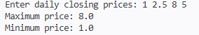
2# An inventory checking system allows a store manager to scan a product ID to see if it is currently in stock. Write a Python program to search for a specific element in a list of product IDs. Example 1: • Input: List=[10,20,30], Item=20 • Output: Found Example 2: • Input: List=[10,20,30], Item=40 • Output: Not Found
products = list(map(int, input("Enter product IDs: ").split()))
item = int(input("Enter product ID to search: "))
for p in products:
if p == item:
print("Found")
break
else:
print("Not Found")
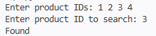

3# A music playlist app needs to organize songs for the user. Write a Python program to take a raw list of song titles and sort the list alphabetically.
songs = input("Enter song titles separated by comma: ").split(",")

for i in range(len(songs)):
songs[i] = songs[i].strip()
songs.sort()
print("Sorted playlist:", songs)
4# An election tally system has a dictionary where keys are candidate names and values are vote counts. Write a Python script to sort this dictionary by value: • First, display the winner (Descending order). • Second, display the candidate with the fewest votes (Ascending order).
votes = {}
n = int(input("Enter number of candidates: "))

for i in range(n):
name = input("Enter candidate name: ")
count = int(input("Enter vote count: "))
votes[name] = count
# Convert dictionary to list of tuples
items = list(votes.items())
# Sort descending for winner
items.sort(key=lambda x: x[1], reverse=True)
print("Winner:", items[0])
# Sort ascending for lowest votes
items.sort(key=lambda x: x[1])
print("Fewest votes:", items[0])

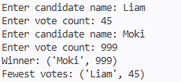
5# A Data Science team is compiling a "Complete Patient Record" from three different hospital departments (General Info, Vitals, and Medical History). Since these departments track completely different metrics, there are no overlapping keys. Write a Python script to concatenate these three distinct dictionaries into one new, single Patient_Profile dictionary. Key Point: Concatenation joins distinct pieces of data together. Example: • Input: o Dept_A = {'Name': 'Shivi', 'Age': 23} o Dept_B = {'Height': 165} o Dept_C = {'BloodType': 'B+'} • Output: {'Name': 'Shivi', 'Age': 23, 'Height': 165, 'BloodType': 'B+'}
Dept_A = {}
Dept_B = {}
Dept_C = {}
n1 = int(input("Enter number of entries for Dept_A: "))
for i in range(n1):
key = input("Enter key: ")
value = input("Enter value: ")
Dept_A[key] = value
n2 = int(input("Enter number of entries for Dept_B: "))
for i in range(n2):
key = input("Enter key: ")
value = input("Enter value: ")
Dept_B[key] = value
n3 = int(input("Enter number of entries for Dept_C: "))
for i in range(n3):
key = input("Enter key: ")
value = input("Enter value: ")
Dept_C[key] = value
Patient_Profile = {}
# Copy Dept_A
for k in Dept_A:
Patient_Profile[k] = Dept_A[k]

# Copy Dept_B
for k in Dept_B:
Patient_Profile[k] = Dept_B[k]
# Copy Dept_C
for k in Dept_C:
Patient_Profile[k] = Dept_C[k]
print("Patient Profile:", Patient_Profile)

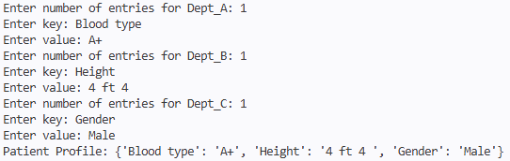
6# An embedded system with very limited memory needs to sort a small buffer of data packets. Write a Python script to implement the Optimized Bubble Sort algorithm. (Implement flag mechanism)
arr = list(map(int, input("Enter numbers: ").split()))
n = len(arr)
for i in range(n):
swapped = False
for j in range(0, n-i-1):
if arr[j] > arr[j+1]:
arr[j], arr[j+1] = arr[j+1], arr[j]
swapped = True

if not swapped:
break

print("Sorted list:", arr)

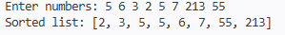
7# A Big Data processing engine needs to sort a massive log file efficiently. Write a Python program to implement the Merge Sort algorithm. You must use recursion to demonstrate the divide-and-conquer methodology. Explain its best, average, and worst-case complexities.
def merge_sort(arr):
if len(arr) <= 1:
return arr
mid = len(arr) // 2
left = merge_sort(arr[:mid])
right = merge_sort(arr[mid:])
result = []
i = 0
j = 0
while i < len(left) and j < len(right):
if left[i] < right[j]:
result.append(left[i])
i += 1
else:
result.append(right[j])
j += 1
while i < len(left):
result.append(left[i])
i += 1
while j < len(right):
result.append(right[j])
j += 1
return result

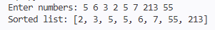

8# A real-time gaming engine needs a high-speed sorting algorithm for rendering objects. Write a Python program to implement the Quick Sort algorithm. Explain its best, average, and worst-case complexities.
def quick_sort(arr):
if len(arr) <= 1:
return arr

pivot = arr[len(arr)//2]

left = []
middle = []
right = []

for x in arr:
if x < pivot:
left.append(x)
elif x == pivot:
middle.append(x)
else:
right.append(x)

return quick_sort(left) + middle + quick_sort(right)

nums = list(map(int, input("Enter numbers: ").split()))
print("Sorted list:", quick_sort(nums))

